**Data Preprocessing**

Data preprocessing involves cleaning and transforming data before it is used for deep learning. This can include tasks such as removing missing values, scaling data, and normalizing data. For example, if a dataset contains missing values, they can be replaced with the mean or median value of the corresponding feature. Similarly, if a dataset contains features with very different scales, such as age and income, they can be scaled to a similar range using techniques such as min-max scaling or z-score normalization.

**Handling Missing Values**

In general it isnt safe to input missing values as 0 as it isnt meaningful. Adequete measures need to be taken depending on the data you have at hand while dealing with missing values. One option is to drop all data that has missing features but in case that the dataset has a lot of missing data you have a chance of losing majority of your data.

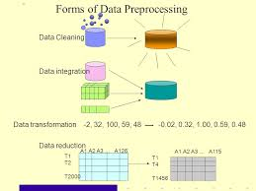

**Feature Engineering**

Involves creating new features from existing data that may be useful for improving the performance of deep learning models. This can include tasks such as selecting important features, creating interaction terms, and transforming data into a more useful form. For example, if a dataset contains information about the length and width of objects, a new feature representing their area could be created by multiplying these two features together. Similarly, text data can be transformed into numerical form using techniques such as one-hot encoding.

Deep learning models have the ability to automatically learn complex features from raw data, which can reduce the need for manual feature engineering. E.g. in computer vision, convolutional neural networks can learn to detect edges, shapes, and textures in images without the need for explicit feature engineering. Similarly, in natural language processing tasks RNNs and transformers can learn to represent text data in a more useful form without the need for explicit feature engineering. But, despite the ability of deep learning models to learn features automatically, feature engineering is still important.

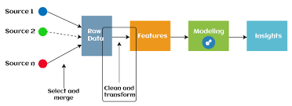

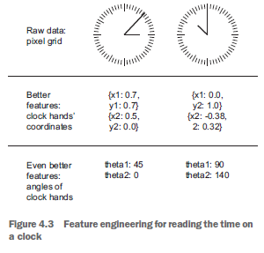

**Diagrammatic representation of both topics in the ‘bigger picture’**

